**Project**

COURSE**:**

**Database Systems**

Submitted to**:**

**Sir  Mukhtiar Zamin**

Topic**:**

**Library Management System**

Submitted by**:** Reg no**:**

**Usman Maqsood FA18-BCS-092**

**Sanaullah Khan FA18-BCS-032**

**M.Muzamil FA18-BCS-096**

**Sardar Ali Irtaza FA18-BCS-022**

**Abdul Wahab FA18-BCS-126**

Date**: 10-09-2020**

Contents

System Description 3

MISSION STATEMENT 4

MISSION OBJECTIVE 5

CONCEPTUAL DATABASE 6

1) Admin 6

2) Student 6

3) Record 6

4) Book 6

5) Books Issued 6

“INDIVIDUAL TASK” 7

Usman Maqsood FA18-BCS-092 8

Admin: 8

CREATE DATABASE [library] 9

Sanaullah Khan FA18-BCS-032 11

Category: 11

Authors: 13

M.Muzamil FA18-BCS-096 14

Books Issued: 14

Sardar Ali Irtaza FA18-BCS-022 17

Book: 17

Abdul Wahab FA18-BCS-126 19

Student: 19

Data Flow Diagram for Students 22

Entity Relationship Diagram 23

Relational Database Schema Script ( SQL SERVER) 24

CREATE DATABASE [library] 24

Entity Relationship Diagram (SQL server) 29

Model Redundancy 29

ER Diagram 29

REFERENCES 30

# System Description

Library management system is all about organizing, managing the library and library-oriented tasks. It also involves maintaining the database of entering new books and the record of books that have been retrieved or issued, with their respective dates.

The main aim of this project is providing an easy to handle and automated library management system. This project also provides features and interface for maintaining librarian’s records, student’s history of issue and fines.

The owner can easily update, delete and insert data in the database with this project. The following are some of the features provided by this project:

The issue of books by online mode.

Columns provided to search book online.

Requests to the librarian can be sent to provide new books in the column.

3

# MISSION STATEMENT

Our team is interested in the current online library management system. We are also eager to know if the current system generation still can incorporate new improvement .

• To save the time and resources.

• To make the processing faster.

• To make it easy to search any record.

• To make the system user friendly.

• To reduce the number of workers.

• To make the backup easily in the events of natural disaster.

# MISSION OBJECTIVE

* To maintain (Enter, Edit and Delete) data on Category
* To maintain (Enter, Update and Delete) data on authors
* To maintain (Enter,Edit, Detail and Delete) data on books
* To maintain (Enter, Update and Delete) data on Books Issued
* To maintain (Enter, Update and Delete) data on record
* To maintain (Enter, Update and Delete) data on Student
* To Search on Category
* To Search on Authors
* To Search on Student
* To Search on Books
* To Search on Issue book
* To Search on Record

# CONCEPTUAL DATABASE

## Admin

This table consists of information about the Admin that is running the library management. This contains ID and password.

**Constraints:**

Admin I.D is unique while password is not NULL because password is mandatory.

## Student

This table consists of information about the record of the library and books inside.

**Constraints:**

Admin I.D is foreign key because there is one to many relationships between **Student & Books Issued**.

## Record

This record contains info about the person that is going to take away books from library.

**Constraints:**

Admin I.D is the foreign key because there is one to many relationships between **Admin & record.**

## Book

This table contains the info about the books of the Library.

**Constraints:**

Copy id is the Primary key as there is one to many relationships between **Book & record**.

## Books Issued

This Table contains info about the person that is going to take away the book.

**Constraints:**

Person I.D is the primary key.

**DATA FLOW DIAGRAMS**

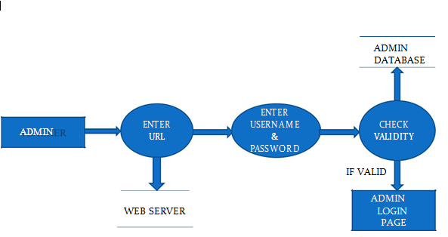

After entering to the home page of the website , Admin can choose the ADMIN LOGIN option where they are asked to enter username & password , and if he/she is a valid Dashboard page will be display.

# “INDIVIDUAL TASK”

## Usman Maqsood FA18-BCS-092

### Admin:

In this table we have two attributes:

1. Admin Id:

This attribute is unique for each Admin Student.

1. Password:

This attribute is unique for each Admin Student.

#### Admin Features

* Admin Dashboard
* Admin can add/update/ delete category
* Admin can add/update/ delete author
* Admin can add/update/ delete books
* Admin can issue a new book to student
* Admin can update the details when student return book
* Admin can search student by using their student ID
* Admin can also view student details
* Admin can change own password

### **CREATE DATABASE [library]**

--

-- Table structure for table `admin`

--

CREATE TABLE `admin` (

`id` int(11) NOT NULL,

`FullName` varchar(100) DEFAULT NULL,

`AdminEmail` varchar(120) DEFAULT NULL,

`UserName` varchar(100) NOT NULL,

`Password` varchar(100) NOT NULL,

`updationDate` timestamp NOT NULL DEFAULT '0000-00-00 00:00:00' ON UPDATE current_timestamp()

) ENGINE=InnoDB DEFAULT CHARSET=latin1;

--

-- Dumping data for table `admin`

--

INSERT INTO `admin` (`id`, `FullName`, `AdminEmail`, `UserName`, `Password`, `updationDate`) VALUES

(1, 'Usman Maqsood', 'usmanmaqsood.263@gmail.com', 'admin', 'f925916e2754e5e03f75dd58a5733251', '2020-12-21 18:11:42');

-- --------------------------------------------------------

| **v** | http://localhost/phpmyadmin/themes/pmahomme/img/designer/exec_small.png | library**admin** |
| --- | --- | --- |
| * id : int(11) | | |
| * FullName : varchar(100) | | |
| * AdminEmail : varchar(120) | | |
| * UserName : varchar(100) | | |
| * Password : varchar(100) | | |
| * updationDate : timestamp | | |

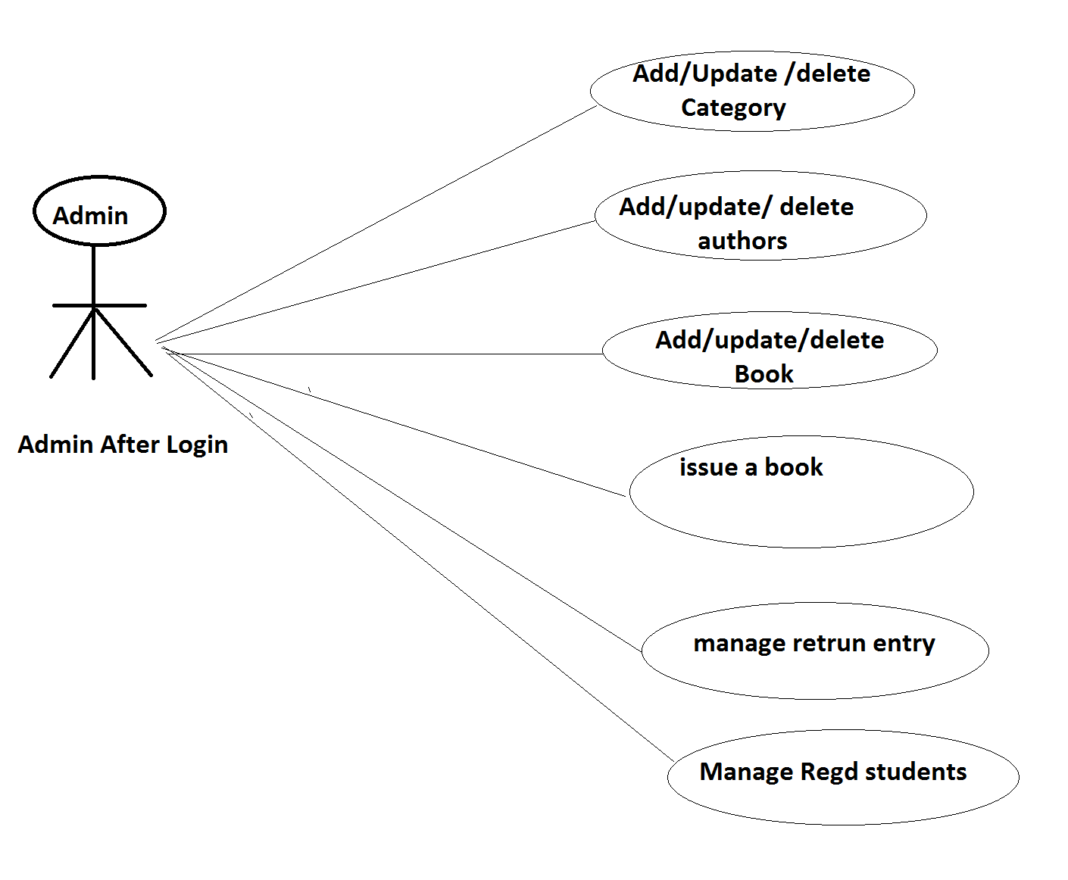

## Sanaullah Khan FA18-BCS-032

**Table 2:-**

### Category:

In this table we have two attributes:

1. Id:

This attribute is unique for each Admin Student.

1. Category Name:

This attribute is keeps record for Category

1. Status:

This attribute shows status of Category **(Active/Inactive)**

1. Creation date:

This attribute keeps record of the creation dates of Author

1. Updation date:

This attribute keeps record of the updation dates of Author

| **v** | http://localhost/phpmyadmin/themes/pmahomme/img/designer/exec_small.png | library**tblcategory** |
| --- | --- | --- |
| * id : int(11) | | |
| * CategoryName : varchar(150) | | |
| * Status : int(1) | | |
| * CreationDate : timestamp | | |
| * UpdationDate : timestamp | | |

--

-- Table structure for table `tblcategory`

--

CREATE TABLE `tblcategory` (

`id` int(11) NOT NULL,

`CategoryName` varchar(150) DEFAULT NULL,

`Status` int(1) DEFAULT NULL,

`CreationDate` timestamp NULL DEFAULT current_timestamp(),

`UpdationDate` timestamp NULL DEFAULT '0000-00-00 00:00:00' ON UPDATE current_timestamp()

) ENGINE=InnoDB DEFAULT CHARSET=latin1;

--

-- Dumping data for table `tblcategory`

--

INSERT INTO `tblcategory` (`id`, `CategoryName`, `Status`, `CreationDate`, `UpdationDate`) VALUES

(8, 'Computer Science', 1, '2020-12-30 08:29:10', '0000-00-00 00:00:00'),

(9, 'Computer Engineering', 1, '2020-12-30 08:29:43', '0000-00-00 00:00:00'),

(10, 'Maths', 1, '2020-12-30 08:42:34', '0000-00-00 00:00:00');

-- --------------------------------------------------------

**Table 3:-**

### Authors:

1. Id:

This attribute is unique for each Author

1. Author Name:

This attribute keep name of Author.

1. Creation date:
2. This attribute shows time of Creation of Author.
3. Updation date:

This attribute shows time of any Updation of Author.

| **v** | http://localhost/phpmyadmin/themes/pmahomme/img/designer/exec_small.png | library**tblauthors** |
| --- | --- | --- |
| * id : int(11) | | |
| * AuthorName : varchar(159) | | |
| * creationDate : timestamp | | |
| * UpdationDate : timestamp | | |

--

-- Table structure for table `tblauthors`

--

CREATE TABLE `tblauthors` (

`id` int(11) NOT NULL,

`AuthorName` varchar(159) DEFAULT NULL,

`creationDate` timestamp NULL DEFAULT current_timestamp(),

`UpdationDate` timestamp NULL DEFAULT NULL ON UPDATE current_timestamp()

) ENGINE=InnoDB DEFAULT CHARSET=latin1;

--

-- Dumping data for table `tblauthors`

--

INSERT INTO `tblauthors` (`id`, `AuthorName`, `creationDate`, `UpdationDate`) VALUES

(1, 'Tariq Baloch', '2020-12-20 12:49:09', '2020-12-20 15:16:59'),

(2, 'Somaya Zaman', '2020-12-20 14:30:23', '2020-12-20 14:30:23'),

(3, 'Dr Usman Khalid', '2020-12-20 14:30:23', '2020-12-20 14:30:23'),

(4, 'muhammad fahab', '2020-11-20 14:30:23', '2020-12-28 16:36:44'),

(5, 'Dr Sehrish Gul', '2020-12-10 14:30:23', '2020-12-10 14:30:23'),

(10, 'Mukhtiar Zamin', '2020-12-30 08:30:21', NULL),

(11, 'Samera Bano', '2020-12-30 08:43:48', NULL);

-- --------------------------------------------------------

## M.Muzamil FA18-BCS-096

**Table 4:-**

### Books Issued:

this table keeps record of the books in the library

1. Book Id:

This attribute is unique for each Book (ISBN)

1. Student id:

This attribute is unique for each Admin Student.

1. Issuedate:

This attribute keeps record of the issue dates of the books.

1. Returndate:

This attribute keeps record of the return dates of the books.

1. Returned status:

This attribute shows status of book (Returned/NoT).

1. Fine/Price/Cost:

This attribute keeps status of fine/cost of books.

| **v** | http://localhost/phpmyadmin/themes/pmahomme/img/designer/exec_small.png | library**tblissuedbookdetails** |
| --- | --- | --- |
| * id : int(11) | | |
| * BookId : int(11) | | |
| * StudentID : varchar(150) | | |
| * IssuesDate : timestamp | | |
| * ReturnDate : timestamp | | |
| * RetrunStatus : int(1) | | |
| * fine : int(11) | | |

--

-- Table structure for table `tblissuedbookdetails`

--

CREATE TABLE `tblissuedbookdetails` (

`id` int(11) NOT NULL,

`BookId` int(11) DEFAULT NULL,

`StudentID` varchar(150) DEFAULT NULL,

`IssuesDate` timestamp NULL DEFAULT current_timestamp(),

`ReturnDate` timestamp NULL DEFAULT NULL ON UPDATE current_timestamp(),

`RetrunStatus` int(1) DEFAULT NULL,

`fine` int(11) DEFAULT NULL

) ENGINE=InnoDB DEFAULT CHARSET=latin1;

--

-- Dumping data for table `tblissuedbookdetails`

--

INSERT INTO `tblissuedbookdetails` (`id`, `BookId`, `StudentID`, `IssuesDate`, `ReturnDate`, `RetrunStatus`, `fine`) VALUES

(7, 4, 'SID01', '2020-12-30 08:36:40', '2020-12-30 09:25:22', 1, 20),

(8, 4, 'SID015', '2020-12-30 08:59:11', NULL, NULL, NULL);

-- --------------------------------------------------------

DATA FLOW DIAGRAM FOR Issuing Book

**Student id**

**ISBN no.**

**Student id**

**ISBN no.**

## Sardar Ali Irtaza FA18-BCS-022

**Table 5:-**

### Book:

In this table we have attributes:

1. Book Id:

This attribute is unique for each new Book (ISBN)

1. Book Name:

This attribute gives name for each new Book

1. Category Id

This attribute assign the book to that category of the book.

1. Author Id

This attribute assign the Authors Id to that New Book

1. ISBN number

This attribute assign the number to the New book.

1. Book Price:

This attribute assign the Price to the New book

1. Reg date:

This attribute assign the Time to the New books.

1. Updation date:

| **v** | http://localhost/phpmyadmin/themes/pmahomme/img/designer/exec_small.png | library**tblbooks** |
| --- | --- | --- |
| * id : int(11) | | |
| * BookName : varchar(255) | | |
| * CatId : int(11) | | |
| * AuthorId : int(11) | | |
| * ISBNNumber : int(11) | | |
| * BookPrice : int(11) | | |
| * RegDate : timestamp | | |
| * UpdationDate : timestamp | | |

This attribute assign the Time of any Updation of the book.

--

-- Table structure for table `tblbooks`

--

CREATE TABLE `tblbooks` (

`id` int(11) NOT NULL,

`BookName` varchar(255) DEFAULT NULL,

`CatId` int(11) DEFAULT NULL,

`AuthorId` int(11) DEFAULT NULL,

`ISBNNumber` int(11) DEFAULT NULL,

`BookPrice` int(11) DEFAULT NULL,

`RegDate` timestamp NULL DEFAULT current_timestamp(),

`UpdationDate` timestamp NULL DEFAULT NULL ON UPDATE current_timestamp()

) ENGINE=InnoDB DEFAULT CHARSET=latin1;

--

-- Dumping data for table `tblbooks`

--

INSERT INTO `tblbooks` (`id`, `BookName`, `CatId`, `AuthorId`, `ISBNNumber`, `BookPrice`, `RegDate`, `UpdationDate`) VALUES

(1, 'PHP And MySql programming', 5, 1, 3322, 20, '2019-12-30 08:31:58', '2020-12-30 09:24:39'),

(3, 'physics', 6, 4, 1111, 15, '2020-11-30 08:31:58', '2020-12-30 09:23:24'),

(4, 'Fundamental Of Programming', 8, 1, 1122, 40, '2020-12-30 08:31:58', NULL),

(5, 'Fundamental Of Logic', 9, 5, 1123, 40, '2020-12-30 08:33:08', '2020-12-30 08:34:52'),

(6, 'Calculus', 10, 11, 2233, 20, '2020-12-30 08:45:24', NULL);

-- --------------------------------------------------------

## Abdul Wahab FA18-BCS-126

**Table 6:-**

### Student:

**Student Have Following Attribute**

1. Student Id:

This attribute is unique for each Admin Student.

1. Full Name:

This attribute keeps Name of a Student.

1. Email Id

This attribute keeps Emails Address of a Student.

1. Mobile Number:

This attribute keeps Mobile Number of a Student.

1. Password:

This attribute keeps Password of a Student.

1. Staus:

This attribute shows status of a Student **(Active/Inactive)**

1. Reg date:

This attribute assign the Time to That New Student.

1. Updation date:

This attribute assign the Time of any updation of Student.

| **v** | http://localhost/phpmyadmin/themes/pmahomme/img/designer/exec_small.png | library**tblstudents** |
| --- | --- | --- |
| * StudentId : varchar(100) | | |
| * FullName : varchar(120) | | |
| * EmailId : varchar(120) | | |
| * MobileNumber : char(11) | | |
| * Password : varchar(120) | | |
| * Status : int(1) | | |
| * RegDate : timestamp | | |
| * UpdationDate : timestamp | | |

--

-- Table structure for table `tblstudents`

--

CREATE TABLE `tblstudents` (

`id` int(11) NOT NULL,

`StudentId` varchar(100) DEFAULT NULL,

`FullName` varchar(120) DEFAULT NULL,

`EmailId` varchar(120) DEFAULT NULL,

`MobileNumber` char(11) DEFAULT NULL,

`Password` varchar(120) DEFAULT NULL,

`Status` int(1) DEFAULT NULL,

`RegDate` timestamp NULL DEFAULT current_timestamp(),

`UpdationDate` timestamp NULL DEFAULT NULL ON UPDATE current_timestamp()

) ENGINE=InnoDB DEFAULT CHARSET=latin1;

--

-- Dumping data for table `tblstudents`

--

INSERT INTO `tblstudents` (`id`, `StudentId`, `FullName`, `EmailId`, `MobileNumber`, `Password`, `Status`, `RegDate`, `UpdationDate`) VALUES

(1, 'SID01', 'Sanaullah Khan', 'vipsanaullahkhan.2000@gmail.com', '3118883615', '7af4896825dfc7e94f8a1d6846a5a2d4', 1, '2020-12-28 13:03:59', '2020-12-30 09:19:55'),

(12, 'SID02', 'Sardar Ali Irtaza', 'sardarali.111@gmail.com', '3114254257', '50d8bd62fbe46030f0b8fe022f80ab26', 1, '2020-12-30 08:49:56', '2020-12-30 09:15:42'),

(13, 'SID03', 'Muhammad Muzamil', 'muzamil.111@gmail.com', '3105025265', '3b84183b2f82038c16e0b6b444f48817', 1, '2020-12-30 08:52:22', '2020-12-30 09:15:49'),

(14, 'SID05', 'Sardar Badar ', 'badar.111@gmail.com', '3101525136', 'dffcec7e95a5b7b3df08820b89601337', 1, '2020-12-30 08:53:40', '2020-12-30 09:16:04'),

(15, 'SID04', 'Samama Saleem', 'samama.263@gmail', '3102564875', '32f69488f68c76a307db13525a47db5a', 1, '2020-12-30 08:55:08', '2020-12-30 09:15:57'),

(16, 'SID017', 'Laraib', 'laraib.123@gmail.com', '3105023255', '8257d23d35ebc9018f744c3069ee5add', 1, '2020-12-30 09:12:39', '2020-12-30 09:15:14'),

(17, 'SID018', 'Hamid Nawaz', 'hamid.123@gmail.com', '3105023265', '0d090b8dc3919dfdf02ce618193a015a', 1, '2020-12-30 09:19:08', NULL);

### Data Flow Diagram for Students

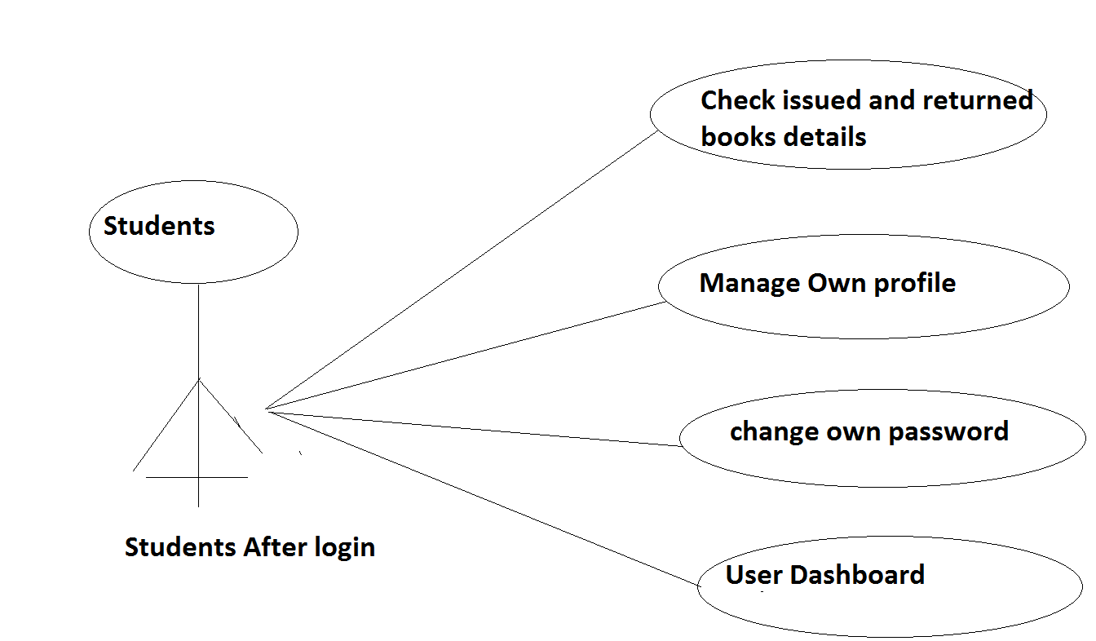

# Entity Relationship Diagram

*Published By*

Author

**BOOK**

*Issued By*

*Borrowed By*

*catogry*

**STUDENT**

**ADMIN**

# Relational Database Schema Script ( SQL SERVER)

### **CREATE DATABASE [library]**

--

-- Table structure for table `admin`

--

CREATE TABLE `admin` (

`id` int(11) NOT NULL,

`FullName` varchar(100) DEFAULT NULL,

`AdminEmail` varchar(120) DEFAULT NULL,

`UserName` varchar(100) NOT NULL,

`Password` varchar(100) NOT NULL,

`updationDate` timestamp NOT NULL DEFAULT '0000-00-00 00:00:00' ON UPDATE current_timestamp()

) ENGINE=InnoDB DEFAULT CHARSET=latin1;

--

-- Dumping data for table `admin`

--

INSERT INTO `admin` (`id`, `FullName`, `AdminEmail`, `UserName`, `Password`, `updationDate`) VALUES

(1, 'Usman Maqsood', 'usmanmaqsood.263@gmail.com', 'admin', 'f925916e2754e5e03f75dd58a5733251', '2020-12-21 18:11:42');

-- --------------------------------------------------------

--

-- Table structure for table `tblauthors`

--

CREATE TABLE `tblauthors` (

`id` int(11) NOT NULL,

`AuthorName` varchar(159) DEFAULT NULL,

`creationDate` timestamp NULL DEFAULT current_timestamp(),

`UpdationDate` timestamp NULL DEFAULT NULL ON UPDATE current_timestamp()

) ENGINE=InnoDB DEFAULT CHARSET=latin1;

--

-- Dumping data for table `tblauthors`

--

INSERT INTO `tblauthors` (`id`, `AuthorName`, `creationDate`, `UpdationDate`) VALUES

(1, 'Tariq Baloch', '2020-12-20 12:49:09', '2020-12-20 15:16:59'),

(2, 'Somaya Zaman', '2020-12-20 14:30:23', '2020-12-20 14:30:23'),

(3, 'Dr Usman Khalid', '2020-12-20 14:30:23', '2020-12-20 14:30:23'),

(4, 'muhammad fahab', '2020-11-20 14:30:23', '2020-12-28 16:36:44'),

(5, 'Dr Sehrish Gul', '2020-12-10 14:30:23', '2020-12-10 14:30:23'),

(10, 'Mukhtiar Zamin', '2020-12-30 08:30:21', NULL),

(11, 'Samera Bano', '2020-12-30 08:43:48', NULL);

-- --------------------------------------------------------

--

-- Table structure for table `tblbooks`

--

CREATE TABLE `tblbooks` (

`id` int(11) NOT NULL,

`BookName` varchar(255) DEFAULT NULL,

`CatId` int(11) DEFAULT NULL,

`AuthorId` int(11) DEFAULT NULL,

`ISBNNumber` int(11) DEFAULT NULL,

`BookPrice` int(11) DEFAULT NULL,

`RegDate` timestamp NULL DEFAULT current_timestamp(),

`UpdationDate` timestamp NULL DEFAULT NULL ON UPDATE current_timestamp()

) ENGINE=InnoDB DEFAULT CHARSET=latin1;

--

-- Dumping data for table `tblbooks`

--

INSERT INTO `tblbooks` (`id`, `BookName`, `CatId`, `AuthorId`, `ISBNNumber`, `BookPrice`, `RegDate`, `UpdationDate`) VALUES

(1, 'PHP And MySql programming', 5, 1, 3322, 20, '2019-12-30 08:31:58', '2020-12-30 09:24:39'),

(3, 'physics', 6, 4, 1111, 15, '2020-11-30 08:31:58', '2020-12-30 09:23:24'),

(4, 'Fundamental Of Programming', 8, 1, 1122, 40, '2020-12-30 08:31:58', NULL),

(5, 'Fundamental Of Logic', 9, 5, 1123, 40, '2020-12-30 08:33:08', '2020-12-30 08:34:52'),

(6, 'Calculus', 10, 11, 2233, 20, '2020-12-30 08:45:24', NULL);

-- --------------------------------------------------------

--

-- Table structure for table `tblcategory`

--

CREATE TABLE `tblcategory` (

`id` int(11) NOT NULL,

`CategoryName` varchar(150) DEFAULT NULL,

`Status` int(1) DEFAULT NULL,

`CreationDate` timestamp NULL DEFAULT current_timestamp(),

`UpdationDate` timestamp NULL DEFAULT '0000-00-00 00:00:00' ON UPDATE current_timestamp()

) ENGINE=InnoDB DEFAULT CHARSET=latin1;

--

-- Dumping data for table `tblcategory`

--

INSERT INTO `tblcategory` (`id`, `CategoryName`, `Status`, `CreationDate`, `UpdationDate`) VALUES

(8, 'Computer Science', 1, '2020-12-30 08:29:10', '0000-00-00 00:00:00'),

(9, 'Computer Engineering', 1, '2020-12-30 08:29:43', '0000-00-00 00:00:00'),

(10, 'Maths', 1, '2020-12-30 08:42:34', '0000-00-00 00:00:00');

-- --------------------------------------------------------

--

-- Table structure for table `tblissuedbookdetails`

--

CREATE TABLE `tblissuedbookdetails` (

`id` int(11) NOT NULL,

`BookId` int(11) DEFAULT NULL,

`StudentID` varchar(150) DEFAULT NULL,

`IssuesDate` timestamp NULL DEFAULT current_timestamp(),

`ReturnDate` timestamp NULL DEFAULT NULL ON UPDATE current_timestamp(),

`RetrunStatus` int(1) DEFAULT NULL,

`fine` int(11) DEFAULT NULL

) ENGINE=InnoDB DEFAULT CHARSET=latin1;

--

-- Dumping data for table `tblissuedbookdetails`

--

INSERT INTO `tblissuedbookdetails` (`id`, `BookId`, `StudentID`, `IssuesDate`, `ReturnDate`, `RetrunStatus`, `fine`) VALUES

(7, 4, 'SID01', '2020-12-30 08:36:40', '2020-12-30 09:25:22', 1, 20),

(8, 4, 'SID015', '2020-12-30 08:59:11', NULL, NULL, NULL);

-- --------------------------------------------------------

--

-- Table structure for table `tblstudents`

--

CREATE TABLE `tblstudents` (

`id` int(11) NOT NULL,

`StudentId` varchar(100) DEFAULT NULL,

`FullName` varchar(120) DEFAULT NULL,

`EmailId` varchar(120) DEFAULT NULL,

`MobileNumber` char(11) DEFAULT NULL,

`Password` varchar(120) DEFAULT NULL,

`Status` int(1) DEFAULT NULL,

`RegDate` timestamp NULL DEFAULT current_timestamp(),

`UpdationDate` timestamp NULL DEFAULT NULL ON UPDATE current_timestamp()

) ENGINE=InnoDB DEFAULT CHARSET=latin1;

--

-- Dumping data for table `tblstudents`

--

INSERT INTO `tblstudents` (`id`, `StudentId`, `FullName`, `EmailId`, `MobileNumber`, `Password`, `Status`, `RegDate`, `UpdationDate`) VALUES

(1, 'SID01', 'Sanaullah Khan', 'vipsanaullahkhan.2000@gmail.com', '3118883615', '7af4896825dfc7e94f8a1d6846a5a2d4', 1, '2020-12-28 13:03:59', '2020-12-30 09:19:55'),

(12, 'SID02', 'Sardar Ali Irtaza', 'sardarali.111@gmail.com', '3114254257', '50d8bd62fbe46030f0b8fe022f80ab26', 1, '2020-12-30 08:49:56', '2020-12-30 09:15:42'),

(13, 'SID03', 'Muhammad Muzamil', 'muzamil.111@gmail.com', '3105025265', '3b84183b2f82038c16e0b6b444f48817', 1, '2020-12-30 08:52:22', '2020-12-30 09:15:49'),

(14, 'SID05', 'Sardar Badar ', 'badar.111@gmail.com', '3101525136', 'dffcec7e95a5b7b3df08820b89601337', 1, '2020-12-30 08:53:40', '2020-12-30 09:16:04'),

(15, 'SID04', 'Samama Saleem', 'samama.263@gmail', '3102564875', '32f69488f68c76a307db13525a47db5a', 1, '2020-12-30 08:55:08', '2020-12-30 09:15:57'),

(16, 'SID017', 'Laraib', 'laraib.123@gmail.com', '3105023255', '8257d23d35ebc9018f744c3069ee5add', 1, '2020-12-30 09:12:39', '2020-12-30 09:15:14'),

(17, 'SID018', 'Hamid Nawaz', 'hamid.123@gmail.com', '3105023265', '0d090b8dc3919dfdf02ce618193a015a', 1, '2020-12-30 09:19:08', NULL);

--

-- Indexes for dumped tables

--

--

-- Indexes for table `admin`

--

ALTER TABLE `admin`

ADD PRIMARY KEY (`id`);

--

-- Indexes for table `tblauthors`

--

ALTER TABLE `tblauthors`

ADD PRIMARY KEY (`id`);

--

-- Indexes for table `tblbooks`

--

ALTER TABLE `tblbooks`

ADD PRIMARY KEY (`id`);

--

-- Indexes for table `tblcategory`

--

ALTER TABLE `tblcategory`

ADD PRIMARY KEY (`id`);

--

-- Indexes for table `tblissuedbookdetails`

--

ALTER TABLE `tblissuedbookdetails`

ADD PRIMARY KEY (`id`);

--

-- Indexes for table `tblstudents`

--

ALTER TABLE `tblstudents`

ADD PRIMARY KEY (`id`),

ADD UNIQUE KEY `StudentId` (`StudentId`);

--

-- AUTO_INCREMENT for dumped tables

--

--

-- AUTO_INCREMENT for table `admin`

--

ALTER TABLE `admin`

MODIFY `id` int(11) NOT NULL AUTO_INCREMENT, AUTO_INCREMENT=2;

--

-- AUTO_INCREMENT for table `tblauthors`

--

ALTER TABLE `tblauthors`

MODIFY `id` int(11) NOT NULL AUTO_INCREMENT, AUTO_INCREMENT=12;

--

-- AUTO_INCREMENT for table `tblbooks`

--

ALTER TABLE `tblbooks`

MODIFY `id` int(11) NOT NULL AUTO_INCREMENT, AUTO_INCREMENT=7;

--

-- AUTO_INCREMENT for table `tblcategory`

--

ALTER TABLE `tblcategory`

MODIFY `id` int(11) NOT NULL AUTO_INCREMENT, AUTO_INCREMENT=11;

--

-- AUTO_INCREMENT for table `tblissuedbookdetails`

--

ALTER TABLE `tblissuedbookdetails`

MODIFY `id` int(11) NOT NULL AUTO_INCREMENT, AUTO_INCREMENT=9;

--

-- AUTO_INCREMENT for table `tblstudents`

--

ALTER TABLE `tblstudents`

MODIFY `id` int(11) NOT NULL AUTO_INCREMENT, AUTO_INCREMENT=18;

COMMIT;

# Entity Relationship Diagram (SQL server)

## Model Redundancy

**All the relations are either one to one or one to many. There is no additional redundancy has been observe.**

## ER Diagram

* Relationship between tables

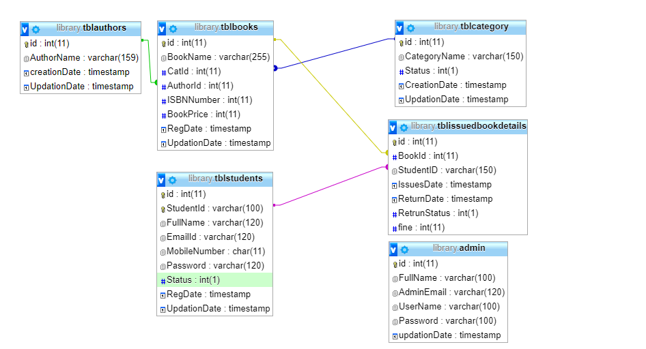

# REFERENCES

[**http://www.w3schools.com/html/html_intro.asp**](http://www.w3schools.com/html/html_intro.asp)

[**https://www.w3schools.com/php/default.asp**](https://www.w3schools.com/php/default.asp)

**https://www.w3schools.com/sql/default.asp**

**\*\*\*\*\*\*\*\*\*\*\*\***